Chapter 4 Founding Colonies in North America

TRUE/FALSE

1. The Headright System began in Virginia.

ANS: T PTS: 1 DIF: Knowledge REF: Chapter 4 Section 3
TOP: English Colonies

2. The waters that surrounded the settlement at Charlesfort were named Port Royal Sound.

ANS: T PTS: 1 DIF: Knowledge REF: Chapter 4 Section 2
TOP: Early Settlements

3. Charlesfort was located on what is today Parris Island.

ANS: T PTS: 1 DIF: Knowledge REF: Chapter 4 Section 2
TOP: Early Settlements

4. An indentured servant agreed to 7 years of work in exchange for passage to America.

ANS: T PTS: 1 DIF: Knowledge REF: Chapter 4 Section 3
TOP: English Colonies

5. A type of colony that was controlled by the king was known as a royal colony.

ANS: T PTS: 1 DIF: Comprehension
REF: Chapter 4 Section 3 TOP: English Colonies

6. New York was first settled by the Swedes.

ANS: F
New York was first settled by the Dutch.

PTS: 1 DIF: Knowledge REF: Chapter 4 Section 3
TOP: English Colonies

7. When the area of New Netherland was conquered by the English, the area of Delaware was given to James, Duke of York.

ANS: T PTS: 1 DIF: Knowledge REF: Chapter 4 Section 3
TOP: English Colonies

8. Spain was the first nation to explore and conquer large sections of the American continents.

ANS: T PTS: 1 DIF: Knowledge REF: Chapter 4 Section 2
TOP: Early Explorers

9. The Puritans were the dominant religious group in New England.

ANS: T PTS: 1 DIF: Knowledge REF: Chapter 4 Section 3
TOP: English Colonies

10. The first permanent English settlement in America was Jamestown in 1607.

ANS: T PTS: 1 DIF: Knowledge REF: Chapter 4 Section 3
TOP: English Colonies

MULTIPLE CHOICE

1. Why did early European explorers come to America?
A. | to obtain tobacco
B. | to civilize the Indians
C. | to find silver and gold
D. | to establish settlements

ANS: C PTS: 1 DIF: Comprehension
REF: Chapter 4 Section 1 TOP: Early Explorers

Columbus’s Journal-1492
(This entry describes Columbus’s encounter with American Indians)

. . . in order that they would be friendly to us--because I recognized that they were people who would be better freed and converted to our Holy Faith by love than by force--to some of them I gave red caps, and glass beads which they put on their chests, and many other things of small value, in which they took so much pleasure and became so much our friends that it was a marvel. Later they came swimming to the ships’ launches where we were and brought us parrots and cotton thread in balls and javelins and many other things, and they traded them to us for other things which we gave them, such as small glass beads and bells. In sum, they took everything and gave of what they had very willingly. But it seemed to me that they were a people very poor in everything. . . .Their javelins are shafts without iron and some of them have at the end a fish tooth. . . .All of them alike are of good sized stature and carry themselves well. I saw some who had marks of wounds on their bodies and I made signs to them asking what they were; and they showed me how people from other islands nearby came there and tried to take them, and how they defended themselves.

2. According to the journal, what product did the Indians give to Columbus?
A. | cotton thread
B. | gold
C. | tobacco
D. | tropical fruit

ANS: A PTS: 1 DIF: Comprehension
REF: Chapter 4 Section 1 TOP: Early Explorers

3. According to the journal, what was Columbus’s plan for the Indians?
A. | He wanted to make them slaves.
B. | He wanted to help them better their lives.
C. | He wanted to convert them to Catholicism.
D. | He wanted to have them lead him to gold and other riches.

ANS: C PTS: 1 DIF: Comprehension
REF: Chapter 4 Section 1 TOP: Early Explorers

4. According to the journal, which statement explains Columbus’s attitude toward the Indians?
A. | He believed they could not be trusted.
B. | He thought they were friendly and peaceful.
C. | He was fearful of them because of their large stature.
D. | He believed they were backward people who could be of no help to him.

ANS: B PTS: 1 DIF: Comprehension
REF: Chapter 4 Section 1 TOP: Early Explorers

5. In his journal, Columbus mentions seeing marks on the bodies of many Indians. What did the marks tell about their life?
A. | The believed in self-mutilation.
B. | They lacked a well-balanced diet.
C. | They engaged in warfare with their neighbors.
D. | They decorated their bodies with paints and dyes.

ANS: C PTS: 1 DIF: Comprehension
REF: Chapter 4 Section 1 TOP: Early Explorers

6. The settlement at San Miguel de Gualdape was doomed from the beginning and lasted only six months. What is the correct chronological order for the following four events, all of which played a role in the abandonment of the settlement?

 | 1. | Lucas Vasques de Ayllon died.
 | 2. | Many died of diseases.
 | 3. | The winter was exceptionally cold.
 | 4. | There was a slave revolt.

A. | 3, 2, 1, 4
B. | 4, 1, 3, 2
C. | 3, 4, 1, 2
D. | 2, 1, 4, 3

ANS: D PTS: 1 DIF: Analysis REF: Chapter 4 Section 1
TOP: Early Explorers

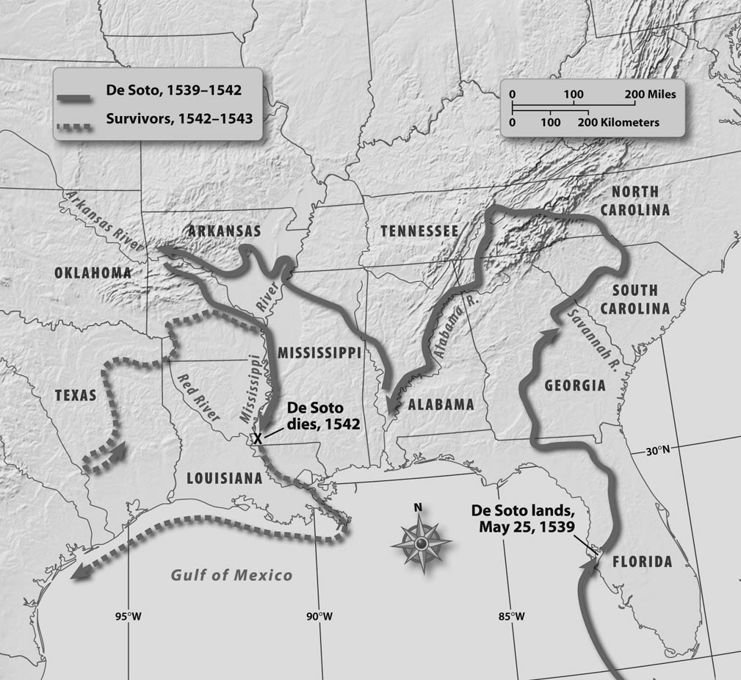

7. According to the map, where did de Soto begin his expedition in North America?
A. | in present-day Florida
B. | in present-day Georgia
C. | in present-day Mississippi
D. | in present-day Tennessee

ANS: A PTS: 1 DIF: Application REF: Chapter 4 Section 2
TOP: Early Explorers

8. According to the map, how many present day states did de Soto and his men explore?
A. | 6
B. | 9
C. | 10
D. | 12

ANS: C PTS: 1 DIF: Application REF: Chapter 4 Section 2
TOP: Early Explorers

9. The voyage of Hernando de Soto covered a large area. What is the correct chronological order for the places de Soto visited on his travels?
 | 1. | present-day Alabama
 | 2. | present-day Florida
 | 3. | present-day South Carolina
 | 4. | present-day Mississippi

A. | 3, 1, 4, 2
B. | 2, 3, 1, 4
C. | 4, 3, 1, 2
D. | 2, 1, 3, 4

ANS: B PTS: 1 DIF: Application REF: Chapter 4 Section 2
TOP: Early Explorers

10. According to the map, what current state did de Soto visit after leaving South Carolina?
A. | Alabama
B. | Florida
C. | Georgia
D. | North Carolina

ANS: D PTS: 1 DIF: Application REF: Chapter 4 Section 2
TOP: Early Explorers

11. Why did all the settlers leave Charlesfort?
A. | They ran out of food.
B. | The Indians killed more than half the settlers.
C. | They believed they had been deserted by their leader.
D. | They were homesick and wanted to return to Europe.

ANS: A PTS: 1 DIF: Comprehension
REF: Chapter 4 Section 2 TOP: Early Settlements

12. What is the correct chronological order of the following European settlements in South Carolina?
 | 1. | Fort San Marcos
 | 2. | Charlesfort
 | 3. | Fort San Felipe
 | 4. | Fort Caroline
 | 5. | San Miguel de Gualdape

A. | 5, 2, 4, 3, 1
B. | 2, 5, 3, 1, 4
C. | 4, 5, 1, 3, 2
D. | 3, 5, 2, 1, 4

ANS: A PTS: 1 DIF: Application REF: Chapter 4 Section 2
TOP: Early Settlements

13. What was the purpose of the Spanish base at Fort San Marcos?
A. | availability of a large mound on which to build a fort
B. | to protect shipping lanes from Mexico, Peru, and the Caribbean islands to Spain
C. | to establish a slave colony
D. | to move away from Florida because of the heat

ANS: B PTS: 1 DIF: Comprehension
REF: Chapter 4 Section 2 TOP: Early Settlements

14. Why is Roanoke Island called the “Lost Colony”?
A. | because it was not discussed in early history books
B. | because no one knows what happened to the settlers
C. | because its location was kept a secret from the Spanish
D. | because it was supposed to be one of the thirteen original colonies

ANS: B PTS: 1 DIF: Comprehension
REF: Chapter 4 Section 3 TOP: English Colonies

15. What was the first permanent English colony in North America?
A. | Jamestown
B. | Plymouth
C. | Roanoke Island
D. | St. Augustine

ANS: A PTS: 1 DIF: Knowledge REF: Chapter 4 Section 3
TOP: English Colonies

The leaders of the Virginia Company recruited more settlers and reorganized the colony. They allowed the new settlers to own land. Those settlers began to grow tobacco, a crop they learned about from the Indians. By 1612, Virginians were shipping tobacco to England, which led other settlers to come over and try their hand at raising the crop. Because growing tobacco required large plots of land, the small tobacco farms grew into large farms, or plantations. Tobacco soon became the backbone of the Virginia economy and the first cash crop grown in America.

16. What is the main idea expressed in the reading?
A. | the bad effects of growing tobacco
B. | the role tobacco played in the economy of Virginia
C. | the attempts of the Virginia Company to recruit settlers
D. | the favorable conditions in Virginia for growing tobacco

ANS: B PTS: 1 DIF: Comprehension
REF: Chapter 4 Section 3 TOP: English Colonies

17. Based on the information in the passage, which statement contains a prediction of what might happen as a result of growing tobacco?
A. | The land will become infertile.
B. | The settlers will leave Virginia.
C. | The large plantations will need more workers.
D. | The market will be flooded with tobacco, causing the price to decrease.

ANS: C PTS: 1 DIF: Analysis REF: Chapter 4 Section 3
TOP: English Colonies

18. What was the name given to people who agreed to work for a certain length of time in exchange for passage to the New World?
A. | indentured servants
B. | sharecroppers
C. | slaves
D. | tenant farmers

ANS: A PTS: 1 DIF: Knowledge REF: Chapter 4 Section 3
TOP: English Colonies

19. What was another name for the Pilgrims?
A. | Congregationalists
B. | Indentured servants
C. | Quakers
D. | Separatists

ANS: D PTS: 1 DIF: Knowledge REF: Chapter 4 Section 3
TOP: English Colonies

20. Which statement does NOT express a view of the Puritans?
A. | They wanted to purify the Anglican Church from Catholicism.
B. | They believed in personal salvation.
C. | They believed that a person’s work was a way to serve God.
D. | They did not believe in strict moral standards.

ANS: D PTS: 1 DIF: Analysis REF: Chapter 4 Section 3
TOP: English Colonies

English Colonies 1607-1732

Colony | Date of Settlement | Leaders | Reasons for Settlement | Type of Colony
Virginia | 1607 | John Smith | Commercial venture | Royal
Massachusetts | 1629 | Puritans (John Winthrop) | Religious freedom | Royal
Maryland | 1632 | Catholics, Calverts | Religious freedom | Proprietary
Connecticut | 1636 | Thomas Hooker | Religious freedom | Royal
Rhode Island | 1644 | Roger Williams and Anne Hutchinson | Religious freedom | Self-governing
New York | 1664 | Dutch (Peter Minuit) | Trade | Royal
New Jersey | 1664 | George Carteret and William Berkeley; Swedes | Farm land | Proprietary/Royal
New Hampshire | 1680 | Puritans | Religious freedom | Royal
Pennsylvania | 1681 | William Penn and Quakers | Equality, antiwar | Proprietary
Delaware | 1704 | William Penn and Quakers | Equality, antiwar | Proprietary
North Carolina | 1712 | Lords Proprietors | Make money from rents | Proprietary/Royal
South Carolina | 1719 | Lords Proprietors | Make money from rents | Proprietary/Royal
Georgia | 1732 | James Oglethorpe | Debtors | Proprietary/Royal

21. According to the chart, what was the primary reason for establishing the English colonies?
A. | to make money for private companies
B. | to establish trade with the Indians
C. | to find a source of gold and silver
D. | to secure religious freedom

ANS: D PTS: 1 DIF: Analysis REF: Chapter 4 Section 3
TOP: English Colonies

22. According to the chart, which colony was established as a haven for Catholics?
A. | Delaware
B. | Maryland
C. | New Jersey
D. | Rhode Island

ANS: B PTS: 1 DIF: Application REF: Chapter 4 Section 3
TOP: English Colonies

23. According to the chart, how long were the English involved in settling the first thirteen colonies?
A. | 100 years
B. | 115 years
C. | 120 years
D. | 125 years

ANS: D PTS: 1 DIF: Application REF: Chapter 4 Section 3
TOP: English Colonies

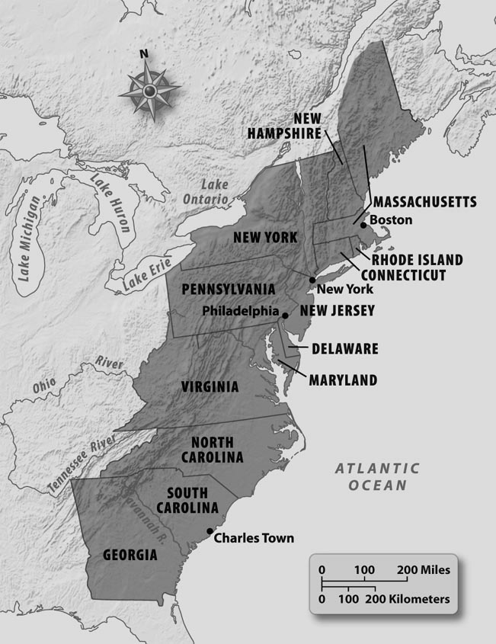

24. Which statement BEST describes the information on the map of the thirteen colonies?
A. | The colonies had different climates.
B. | The colonies were settled in the 1600s.
C. | The colonies bordered the Atlantic Ocean.
D. | The colonies had problems with the French.

ANS: C PTS: 1 DIF: Application REF: Chapter 4 Section 3
TOP: English Colonies

25. According to the map, what was the most westward of the thirteen colonies?
A. | Florida
B. | Georgia
C. | Gulf of Mexico
D. | Mississippi River

ANS: B PTS: 1 DIF: Application REF: Chapter 4 Section 3
TOP: English Colonies

26. Which country was NOT a major colonizer of the New World?
A. | England
B. | France
C. | Italy
D. | Spain

ANS: C PTS: 1 DIF: Analysis REF: Chapter 4 Section 3
TOP: Early Explorers

27. Which group of English colonies had the mildest climate?
A. | New England Colonies
B. | Middle Colonies
C. | Southern Colonies
D. | Western Colonies

ANS: C PTS: 1 DIF: Application REF: Chapter 4 Section 3
TOP: English Colonies

28. Which group of colonies was characterized by rugged terrain, rocky soil, and harsh weather?
A. | New England Colonies
B. | Middle Colonies
C. | Southern Colonies
D. | Western Colonies

ANS: A PTS: 1 DIF: Knowledge REF: Chapter 4 Section 3
TOP: English Colonies

29. Which South Carolina lady showed De Soto hospitality?
A. | Pocahontas
B. | Cofitachiqui
C. | Jean Ribault
D. | Saint Elena

ANS: B PTS: 1 DIF: Knowledge REF: Chapter 4 Section 2
TOP: Early Explorers

30. Jamestown had a very uncertain and miserable existence for many years because
A. | they found lots of gold.
B. | the people would not work.
C. | the weather was always bad.
D. | the owners were lacking in ability.

ANS: D PTS: 1 DIF: Analysis REF: Chapter 4 Section 3
TOP: English Colonies

31. Massachusetts Bay Company was a Puritan settlement that believed
A. | the new land was not for farmers.
B. | they were God’s agent in changing the world.
C. | the Indians would help them grow food supplies.
D. | the winters were too severe so they went back to England.

ANS: B PTS: 1 DIF: Comprehension
REF: Chapter 4 Section 3 TOP: English Colonies

COMPLETION

1. The first legislative body in America was the _________________________.

ANS: House of Burgesses

PTS: 1 DIF: Knowledge REF: Chapter 4 Section 2
TOP: English Colonies

2. The Puritans wanted to separate from the _________________________.

ANS: Anglican Church

PTS: 1 DIF: Comprehension REF: Chapter 4 Section 3
TOP: English Colonies

3. Pilgrims came to Massachusetts aboard the ____________________.

ANS: Mayflower

PTS: 1 DIF: Knowledge REF: Chapter 4 Section 3
TOP: English Colonies

4. Some historians believe the South Carolina settlement at San Miguel de Gualdape might have been established near the ____________________ River.

ANS: Waccamaw

PTS: 1 DIF: Comprehension REF: Chapter 4 Section 2
TOP: Early Settlements

5. The first explorer to possibly see the interior of the present-day state of South Carolina was ___________________.

ANS: Hernando de Soto

PTS: 1 DIF: Knowledge REF: Chapter 4 Section 3
TOP: Early Explorers

6. The first effort to establish an English colony in North America on the outer banks of present-day North Carolina was lead by _______________________.

ANS: Sir Walter Raleigh

PTS: 1 DIF: Knowledge REF: Chapter 4 Section 3
TOP: English Colonies

7. The proprietor of the Maryland Colony was __________________________.

ANS: Cecilius Calvert, Lord Baltimore

PTS: 1 DIF: Knowledge REF: Chapter 4 Section 3
TOP: English Colonies

8. Puritan leaders founded __________________College to train new pastors.

ANS: Howard

PTS: 1 DIF: Knowledge REF: Chapter 4 Section 3
TOP: English Colonies

9. _______________________founded the colony of Connecticut.

ANS: Thomas Hooker

PTS: 1 DIF: Knowledge REF: Chapter 4 Section 3
TOP: English Colonies

10. The areas around Manhattan Island and the Hudson River were claimed by the __________________

ANS: Netherlands

PTS: 1 DIF: Knowledge REF: Chapter 4 Section 3
TOP: English Colonies

11. The ______________________rejected the use of force and violence and refused to serve in the military.

ANS: Quakers

PTS: 1 DIF: Comprehension REF: Chapter 4 Section 3
TOP: English Colonies

MATCHING

Match the term with its definition.
A. | cartographer | E. | inept
B. | dictatorial | F. | piety
C. | garrison | G. | prefabricated
D. | heretic

1. devotion

2. controlling in a forceful way

3. someone whose beliefs go against official religious beliefs

4. already built

5. mapmaker

6. lacking ability

7. a group of soldiers

1. ANS: F PTS: 1 DIF: Knowledge REF: Chapter 4 Section 1
TOP: Vocabulary

2. ANS: B PTS: 1 DIF: Knowledge REF: Chapter 4 Section 3
TOP: Vocabulary

3. ANS: D PTS: 1 DIF: Knowledge REF: Chapter 4 Section 2
TOP: Vocabulary

4. ANS: G PTS: 1 DIF: Knowledge REF: Chapter 4 Section 1
TOP: Vocabulary

5. ANS: A PTS: 1 DIF: Knowledge REF: Chapter 4 Section 3
TOP: Vocabulary

6. ANS: E PTS: 1 DIF: Knowledge REF: Chapter 4 Section 3
TOP: Vocabulary

7. ANS: C PTS: 1 DIF: Knowledge REF: Chapter 4 Section 2
TOP: Vocabulary

ESSAY

1. Describe the Lost Colony of Roanoke Island, including who was responsible for the settlement, where the settlement was made, the leader of the colony, and what happened to the colony.

ANS:
Person responsible for the settlement: Sir Walter Raleigh
Where the settlement was made: Outer Banks of North Carolina
Leader of the colony: John White
What happened to the colony:
White returned to England for supplies.
When White returned, the settlement had been abandoned.
There were no signs of the settlers or any clues to their whereabouts.

PTS: 1 DIF: Analysis | Comprehension REF: Chapter 4 Section 1
TOP: English Colonies

